Breece Mobile Assist light (for IOS) – the guide. (Version 0.1 2019-08-06)

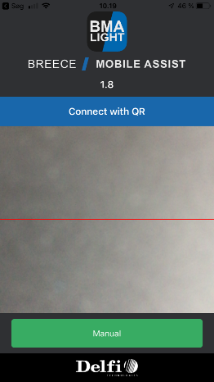
Logging in:
When opening the app the first thing to see is the log-on screen.
Here it is possible to scan the provided QR-code (user) and the app will automatically log in.

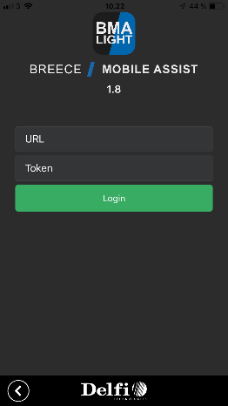
An alternative way to log in is to click the button “Manual” – here it is possible to manually type the login details (URL and Token). When done click “Login” and the app logs in.

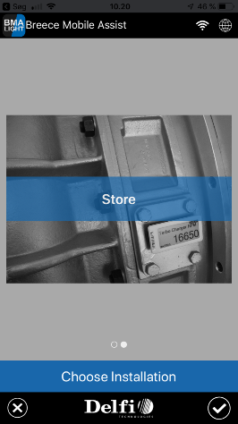
If the user has access to multiple installations, then this screen will show.
Here the user can choose which installation the user wish to log on to.
Swipe left/right till the right installation appears and click the “OK”-button (checkmark) in the lower right corner.
-When user has access to only one installation this step is skipped.

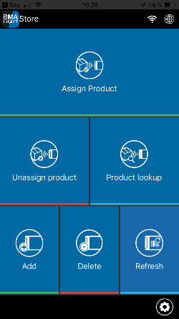
When user is logged in the main menu appears – from here it is possible to:
Assign: In this menu it is possible to assign products/values to Display/Vision/Vision4K
Unassign: In this menu it is possible to unassign products/values to Display/Vision/Vision4K
Refresh: In this menu it is possible to force update a display
Product lookup: In this menu it is possible to look at details of a product(s) and see position if any. Display serial number can be used as input
Add display: In this menu it is possible to add displays to the installation Delete display: In this menu it is possible to add displays to the installation Configuration: Is accessed in the lower right corner (wheel)
Just click on the menu tile to access the functionality.

Configuration: See the configuration received from cloud. Here it is also possible to change the installation the user is logged on to and logout (to later log in with different user).
To change the configuration go to cloud GUI – in GUI see details of each possible setting.

Assign product:
When clicking the assign product the user needs to scan or type a display serial number, Vision serial number or Vision4K serial number. Depending on the type of input the app will proceed to one of the following functions-
Assign product (Display):
After scanning/typing the display serial number the app will ask for at product serial number. This can be scanned or typed. In the top left corner the layout is shown (if 1x1 layout a grey box is shown). To change the layout click the grey box or swipe from right to left. This will open the layout selector. Depending on the layout the app will expect at least one product input but might be multiple.
After product input click the “ok”-button in the bottom right corner to assign the product(s) to the display. The app will now return to the scan/type display screen and is ready for new assign.

Assign product (Vision):
After scanning/typing the Vision serial number the app will ask for configuration and layout details
When this is selected the user can start scanning/typing the product input. Follow the number of product input in the layout in the top left/right corner. When done simply click the “ok”-button.
The app will jump to the Vision overview page. If using split screen layout it is possible to swipe left/right to access product on the opposite side of the screen.
Change product – the click the product line and make new input.
See product description - the click the product line and click “back”.
Change position of product – click, hold and drag the product line to new position.
-Click “Next” from the vision overview to make final assignment.

Assign product (Vision4K):
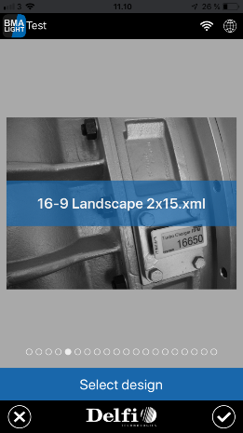
After scanning/typing the Vision4K serial number and the Vision4K is not currently assigned the app will ask for the design to be used. Swipe left/right to see the possible designs. Click the “ok”-button (checkmark) to select the design.

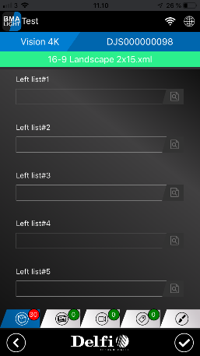
From the vision4k overview screen it is possible the add/change product input.
Use the taps at the bottom the change/make input to Images, video, or parameters. The final tap to the right will make it possible to change the design.
Beside each product input line it is possible to click the “detail” button – this will show where the product details are shown on the design. Click back to return to the overview screen.
-Click the “ok”-button (checkmark) in the lower right corner to make final assignment

Further information:
Works only with internet.
Functionality currently avalable: Assign (display, vision, V4K), Unassign (display, vision, V4K), Product lookup (display, product, reordercode), Add (display), Delete (display), Refresh (display, V4K).
Positions is not a part of this
Flash is a part of this
Message center is not a part of this
Menu tile configuration is not a part of this

